MID-TERM PROJECT REPORT
Software Engineering Course

Project Information
Project Title: CityRide - RESEARCH AND DEVELOPMENT OF A SMART RIDE-HAILING SYSTEM ON MOBILE PLATFORMS
Course: Software Engineering
Team Name: 403
Instructor: TS. Nguyễn Thanh Tuấn
University: Trường Đại học Công nghệ Thông tin và Truyền thông Việt Hàn
Submission Date: 14/05/2026

Team Members
No | Student ID | Full Name | Role
1 | 24IT119 | Lê Đăng Khoa | Scrum Master and Business Analyst
2 | 24IT233 | Nguyễn Hiền Tâm | Business Analyst and Developer
3 | 24IT010 | Trần Nguyễn Tuấn Anh | Business Analyst and Developer
4 | 24IT251 | Huỳnh Thị Thanh Thảo | Tester
5 | 24IT310 | Nguyễn Trương Quang Vinh | Tester

1. Introduction
1.1 Project Overview
The project “Research and Development of a Smart Ride-Hailing System on Mobile Platforms” is designed to address the difficulties users often face in transportation and travel planning. In reality, many customers experience inconvenience when booking rides, tracking trips, making payments, or searching for suitable tourist destinations, restaurants, and accommodations. In addition, most existing applications mainly focus on transportation services and do not provide smart tourism support powered by artificial intelligence.
The system is developed for multiple target users, including passengers, drivers, transportation businesses, customer support staff, and system administrators. The proposed solution is a smart mobile application that allows users to book rides quickly, track journeys in real time on a map, make online payments, and receive personalized travel recommendations from an AI travel assistant. The AI assistant can suggest destinations, travel schedules, hotels, restaurants, and other services based on the user’s preferences and needs. Through these features, the system aims to improve user experience, optimize service management, and contribute to the development of modern digital tourism services.

1.2 Project Objectives
The project “Research and Development of a Smart Ride-Hailing System on Mobile Platforms” is carried out with the following objectives:
- To analyze and develop an intelligent ride-booking system that operates on mobile platforms, meeting users’ needs for fast, convenient, and safe transportation services.
- To develop a functional software prototype that includes a user interface, database management system, and core application functionalities.
- To implement the main features of the proposed system, including:
- User registration, login, and account management.
- Ride booking and real-time trip tracking on maps.
- Trip receiving and processing for drivers.
- Payment processing and invoice management.
- Rating and feedback functions for service quality evaluation.
- Customer support services.
- Integration of an AI travel assistant to recommend destinations, schedules, and suitable travel services for users.
- To build an administration system for business owners to manage users, drivers, revenue, and operational statistics.
- To apply the Agile software development methodology in order to improve flexibility, adaptability, and teamwork efficiency during the development process.
- To use Git/GitHub version control systems for source code management, change tracking, and team collaboration.
- To apply modern technologies in mobile application and backend development to enhance system performance, scalability, and security.
- To improve team members’ skills in requirement analysis, system design, programming, testing, and software deployment through practical project implementation.
- To establish a foundation for future system expansion with advanced features such as AI-based ride demand prediction, route optimization, electronic payment integration, and personalized user experiences.

1.3 Development Methodology
The project is developed using the Agile methodology, specifically the Scrum framework, to improve flexibility, adaptability to changing requirements, and team collaboration efficiency throughout the development process.
The development process is divided into short cycles called Sprints. Each Sprint focuses on developing a specific set of features within a fixed period of time. At the end of every Sprint, the team reviews the completed work, performs testing, and improves the system before proceeding to the next Sprint.
The project is divided into multiple Sprints, with each Sprint lasting approximately 1 to 2 weeks.
During each Sprint, the team performs the following activities:
- Sprint Planning: Defining objectives, selecting features to implement, and assigning tasks to team members.
- System Design and Development: Developing user interfaces, implementing functionalities, and integrating system components.
- Testing and Debugging: Conducting functional testing, identifying bugs, and fixing issues to ensure system stability and performance.
- Sprint Review and Sprint Retrospective: Reviewing completed work, presenting implemented features, and discussing improvements for future Sprints.
The project team is organized according to Scrum roles to ensure effective collaboration and project management.
- Scrum Master: Manages the development process, organizes Scrum meetings, supports the team in solving problems, and ensures Agile practices are followed.
- Developers: Design and develop frontend, backend, database, and system functionalities.
- Testers: Perform functional testing, identify bugs, evaluate software quality, and ensure system reliability.
The team uses several tools to support development, collaboration, and project management throughout the project lifecycle.
- GitHub: Source code management and version control
- Trello / Jira: Task management and Sprint tracking
- Figma: User interface and prototype design
- Visual Studio Code: Source code development and editing
- MySQL: Database management
- Postman: API testing and backend integration
Applying the Agile Scrum methodology helps the team quickly adapt to requirement changes, improve collaboration efficiency, and maintain software quality throughout the project development lifecycle.

2. Requirements
2.1 Stakeholders
Stakeholders are individuals or groups that are directly or indirectly related to the system and may influence or be affected by the project development process.
The stakeholders of the system include:
- End Users (Customers): Users who use the mobile application to book rides, manage trips, make payments, and receive travel recommendations from the AI assistant.
- Drivers: Individuals who receive ride requests, manage trips, and provide transportation services through the system.
- Business Owners: People responsible for managing business operations, monitoring revenue, drivers, users, and system activities.
- System Administrators: Responsible for managing the system, maintaining security, handling user permissions, and ensuring stable system operation.
- Development Team: Includes developers, testers, designers, and Scrum Master who participate in analyzing, designing, developing, and testing the system.
- Project Supervisor / Lecturer: Supervises the project progress, provides guidance, evaluates the project quality, and supports the development process.
- Payment Service Providers: Third-party payment systems integrated into the application to support online payment transactions.
- AI Service Providers: External AI or recommendation services that support intelligent travel suggestions and personalized experiences for users.

2.2 Functional Requirements
Functional requirements describe what the system should do to satisfy user needs during the operation of the intelligent ride-booking system integrated with an AI travel assistant on a mobile platform.
ID | Requirement | Description
FR1 | User Registration | Users can create a new account using a phone number, email, or social media account.
FR2 | User Login | Users and drivers can log into the system to access their corresponding features.
FR3 | Forgot Password | Users can recover or reset their password through OTP or email verification.
FR4 | Ride Booking | Customers can enter pickup and destination locations and choose a vehicle type to create a trip.
FR5 | Trip Tracking | Users can track the driver’s location and trip status in real time on the map.
FR6 | Online Payment | The system supports payments via cash, e-wallets, or bank cards.
FR7 | Trip History Management | Users can view previous trips and detailed invoice information.
FR8 | Rating and Feedback | Customers can rate drivers and provide feedback after completing a trip.
FR9 | AI Travel Assistant | The AI system can recommend tourist attractions, restaurants, hotels, and suitable travel itineraries for users.
FR10 | Customer Support | Users can send support requests or chat with support staff when problems occur.
FR11 | User Management | Administrators can add, edit, lock, or delete user and driver accounts.
FR12 | Revenue and Statistics Management | Business owners and revenue managers can view revenue reports, trip statistics, and invoices over time.

2.3 Non‑Functional Requirements
Non-functional requirements describe the quality attributes and operational constraints of the system, including performance, security, usability, reliability, and scalability.
ID | Requirement | Description
NFR1 | Performance | The system response time must be less than 2 seconds for normal user requests.
NFR2 | Security | User data and payment information must be securely stored and encrypted.
NFR3 | Concurrent Users Support | The system must support multiple users accessing the application simultaneously without performance degradation.
NFR4 | Availability | The system should operate continuously with high availability and minimal downtime.
NFR5 | Scalability | The system must be easily scalable to support increasing numbers of users and trips in the future.
NFR6 | Usability | The mobile application interface must be user-friendly, intuitive, and easy to navigate.
NFR7 | Compatibility | The application must support Android and iOS mobile platforms.
NFR8 | Reliability | The system must ensure accurate trip, payment, and location processing with minimal errors.
NFR9 | Data Backup | System data must be backed up regularly to prevent data loss.
NFR10 | Maintainability | The system architecture and source code should be modular and easy to maintain or upgrade.

2.4 User Stories
User stories describe the system requirements from the user’s perspective.
ID | User Story
US1 | As a customer, I want to create an account so that I can access the system and use ride-booking services.
US2 | As a customer, I want to log into the application so that I can manage my trips and personal information.
US3 | As a customer, I want to book a ride by selecting pickup and destination locations so that I can travel conveniently.
US4 | As a customer, I want to track the driver’s location in real time so that I can know when the driver will arrive.
US5 | As a customer, I want to make online payments so that I can complete transactions quickly and securely.
US6 | As a customer, I want to receive AI-based travel recommendations so that I can discover suitable tourist destinations and services.
US7 | As a driver, I want to receive and manage trip requests so that I can provide transportation services efficiently.
US8 | As an administrator, I want to manage users and system reports so that I can monitor and maintain system operations effectively.

3. System Design (C4 Model)
Definition:
- C4 Model is a software architecture modeling method developed by Simon Brown to make system design and presentation more visual, clear, and easier to understand.
- The name “C4” comes from four different diagram levels:
+ Context Diagram
+ Container Diagram
+ Component Diagram
+ Code Diagram
- This model allows developers to describe a system from a high-level overview down to the detailed source code level.
- C4 Model was created to replace traditional UML diagrams, which are often considered complicated and difficult for many people to understand.
- By dividing the system into multiple abstraction levels, C4 helps readers understand:
+ How the system works
+ The components inside the system
+ How components communicate with each other

- Nowadays, C4 Model is widely used in:
+ Web Applications
+ Mobile Applications
+ Enterprise Systems
+ Microservice Architectures

Purpose:
- The main purpose of the C4 Model is to describe software architecture in a more visual and communicative way among project members.
This model helps:
+ Developers understand system structure
+ Testers understand processing flows
+ Project managers understand the overall architecture
+ Clients visualize the system more easily
- C4 also supports:
+ System analysis
+ Software design
+ System maintenance
+ Future feature expansion
- In addition, C4 Model helps create clearer system documentation and reduces communication time between development team members.
- Using C4 also helps identify:
+ Important system components
+ Technologies used
+ Relationships between modules
+ Data communication flows
Characteristics:
- C4 Model is known for being simpler, more visual, and easier to read compared to traditional UML diagrams.
- This model divides software architecture into multiple levels so readers can move from a general overview to detailed technical structures.
- C4 focuses on real-world system components such as:
+ Frontend
+ Backend
+ API
+ Database
+ Redis
+ External Services
- C4 diagrams usually use:
+ Simple boxes
+ Communication arrows
+ Short descriptions
- This makes diagrams:
+ Easy to read
+ Easy to update
+ Easy to expand
- C4 is suitable for many modern software development approaches such as:
+ Agile
+ DevOps
+ Microservice Architecture
- In addition, C4 helps development teams organize tasks and manage systems more effectively.

3.1 System Context Diagram
Definition:
- Context Diagram is the first and highest-level diagram in the C4 Model.
- This diagram describes the system as a “black box” and focuses on:
+ Who uses the system
+ Which external systems interact with the system
- Context Diagram does not go deeply into technical details but instead focuses on the overall picture of the system.
- Common elements in this diagram include:
+ User
+ Admin
+ External System
+ Main System

Purpose:
- Helps readers quickly understand the role of the system in the real environment.

- Supports project introduction for:
+ Clients
+ Managers
+ New team members
- Helps identify:
+ System users
+ Related systems
+ Software boundaries

Characteristics:
- Only describes the overall system.
- Does not describe:
+ Database
+ Source code
+ Internal business logic
- Diagrams are usually simple and easy to understand.
- Focuses on relationships between the system and external environments.

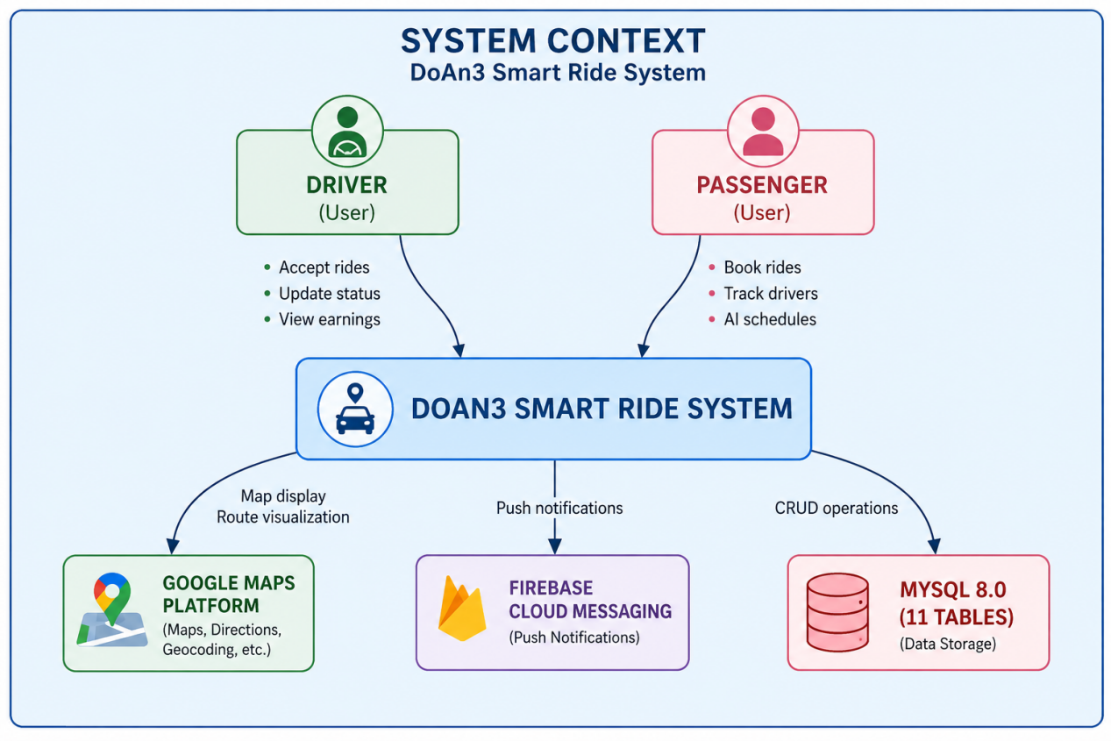

3.2 Container Diagram

Definition:
- Container Diagram is the second level in the C4 Model and describes the major parts inside the system.

- The term “Container” here does not refer to Docker containers. Instead, it refers to large functional blocks such as:
+ Web Application
+ Mobile Application
+ Backend API
+ Database
+ Redis
+ Microservices
- This diagram helps present the overall structure of the system and how the containers communicate with each other.

Purpose:
- Helps understand the overall architecture of the system.
- Shows:
+ Data processing flow
+ Connections between containers
+ Technologies used in each part
- Supports:
+ System design
+ System management
+ Task distribution for the development team

Characteristics:
- More detailed than the Context Diagram.
- Each container usually includes:
+ Name
+ Responsibility
+ Technology used
- The diagram clearly shows:
+ Frontend communication with Backend
+ Backend connection with Database
+ Communication between services
- This is the most commonly used level in practice because it clearly describes system architecture.

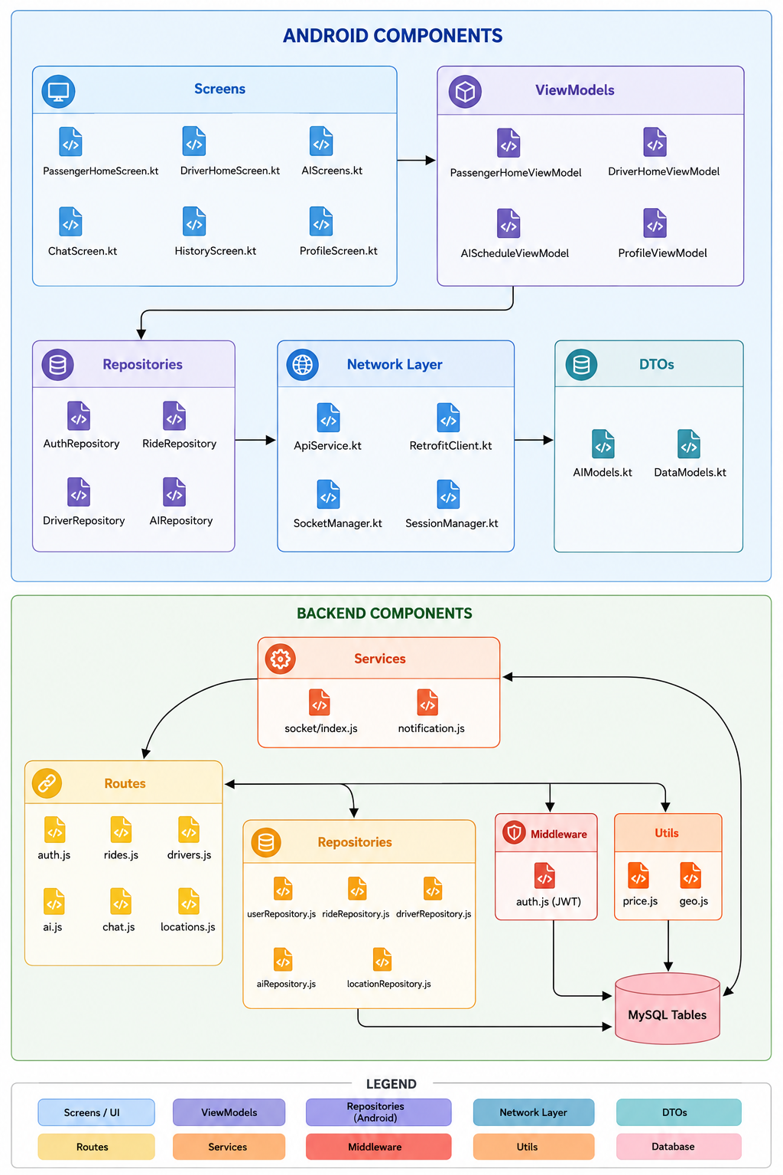

3.3 Component Diagram

Definition:
- Component Diagram is the third level in the C4 Model and is used to describe the internal modules inside a container.
- If the Container Diagram shows the major parts of the system, the Component Diagram explains what exists inside those parts.
- Common components include:
+ Controller
+ Service
+ Repository
+ Interface
+ Helper
+ Business Module
- This diagram helps developers better understand the internal structure of the application and the relationships between modules.

Purpose:
- Helps developers understand internal system architecture.
- Supports task division among team members.
- Makes maintenance and system expansion easier.
- Helps organize source code more effectively.

Characteristics:
- More detailed than the Container Diagram.
- Focuses on business logic and internal processing.
- Shows communication between modules inside a container.
- Often used by backend developers and software architects during development.

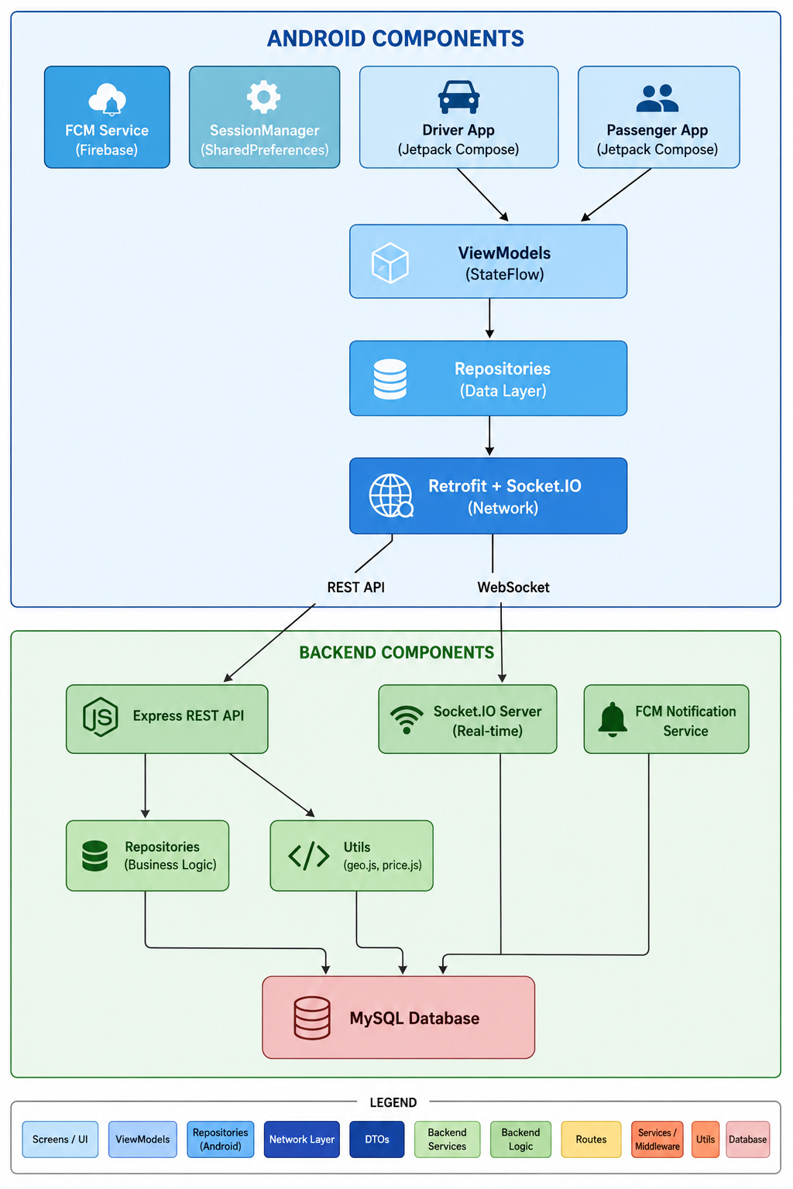

3.4. Code Diagram

Definition:
- Code Diagram is the most detailed level in the C4 Model.
- It directly describes the source code structure of the system, including:
+ Classes
+ Interfaces
+ Methods
+ Attributes
+ Inheritance relationships
- This level is similar to UML Class Diagrams.

Purpose:
- Supports detailed software design.
- Helps developers understand source code structure.
- Assists in analyzing complex functionalities.
- Improves understanding of relationships between classes and objects.

Characteristics:
- Contains a very high level of detail.
- Closely related to the actual source code.
- Useful for complex systems and advanced analysis.
- Difficult to maintain when the source code changes frequently.
- Usually used in large-scale or enterprise systems where detailed design is necessary.

4. Development
4.1 Technologies Used
Category | Technology | Description
Front-end | Kotlin, Jetpack Compose, Retrofit | Used to develop a modern Android mobile application with responsive user interfaces and efficient API communication.
Back-end | PHP, RESTful API | Handles business logic, user, authentication, trip management, payment processing, and system operations.
Database | MySQL | Stores data related to users, drivers, trips, payments, invoices, and travel information.
Framework | Jetpack Compose, Retrofit | Supports Android UI development using a modern declarative approach with reusable components and better performance.
Tools | Android Studio, Visual Studio Code, XAMPP, Postman, GitHub, Figma | Used for application development, backend programming, API testing, local server management, version control, and UI/UX design.
Additionally, the system integrates Google Maps API for map navigation, real-time location tracking, and route management. The AI Travel Assistant feature is designed to support users with destination suggestions and travel recommendations.

4.2 Development Process
The project “Research and Development of a Smart Ride-Hailing System on Mobile Platforms” was developed using an iterative sprint-based development process. Each sprint focused on a specific group of features to ensure systematic implementation, easier testing, and continuous improvement throughout the development lifecycle.
Sprint | Implemented Features
Sprint 1 | Requirement analysis, system design, database design, user authentication, account registration, login, and password recovery functions.
Sprint 2 | Development of core system features including ride booking, driver management, trip tracking, trip history, invoice and payment management, and Google Maps API integration.
Sprint 3 | Development of AI Travel Assistant features, destination suggestions, customer support functions, user profile management, and rating/feedback system.
Sprint 4 | API integration, frontend-backend connection, interface optimization, bug fixing, and performance improvements.
Sprint 5 | System testing, security checking, usability testing, debugging, final optimization, and deployment preparation.

During the development process, the team continuously evaluated the system after each sprint to identify issues and improve system performance. This development approach helped ensure better project management, stable feature integration, and improved user experience for the final application.

4.3 GitHub Repository
GitHub Repository:

5. Testing
This section describes how the system was tested.

5.1 Testing Strategy
Explain the testing approach used in the project.
Examples:
• Unit Testing

• Integration Testing
• System Testing

5.2 Test Cases
Provide some example test cases.
Test ID Feature Input Expected Result
TC1 Login Valid account User logs in
successfully

TC2 Login Wrong
password

Error message
displayed

Provide at least 5 test cases.

5.3 Testing Results
Summarize the testing outcomes.
Explain:
• Whether the system passed the tests
• Any bugs discovered
• Possible improvements

6. Deployment
This section describes where and how the system is deployed.

6.1 Deployment Environment
Example:
Component Platform
Backend Render / AWS
Frontend Vercel / Netlify
Database MongoDB Atlas

6.2 System Access
Provide links to access the system.
Application URL:
GitHub Repository:

6.3 Demo Video
Provide a video demonstrating the system.

Demo Video Link:
The demo should show:
• System overview
• Main features
• Example usage
Recommended length: 3–5 minutes.
7. Conclusion
After the process of researching, designing, and implementing the project, the “Smart Ride Booking System Integrated with AI Travel Assistant on Mobile Platform” successfully achieved its main objectives by developing an Android-based ride booking application with features such as user authentication, ride booking, trip tracking, invoice management, and AI-based travel recommendations. During development, the team faced challenges related to API integration, real-time synchronization, and Google Maps integration, but these issues were resolved through continuous testing and system improvements. In the future, the system can be enhanced by adding online payment features, improving AI capabilities, supporting iOS devices, and optimizing overall system performance.

8. References
- Agile Alliance, “Manifesto for Agile Software Development”, Available at: http://agilemanifesto.org/
- Android Developers, “Jetpack Compose Documentation”, Available at: https://developer.android.com/jetpack/compose
- Kotlin Documentation, “Kotlin Programming Language”, Available at: https://kotlinlang.org/docs/home.html
- Retrofit Documentation, “Type-safe HTTP Client for Android”, Available at: https://square.github.io/retrofit/
- PHP Documentation, “PHP Manual”, Available at: https://www.php.net/docs.php
- MySQL Documentation, “MySQL Reference Manual”, Available at: https://dev.mysql.com/doc/
- Postman Learning Center, “API Testing Documentation”, Available at: https://learning.postman.com/
- GitHub Documentation, “Version Control and Collaboration”, Available at: https://docs.github.com/
- Google Maps Platform Documentation, “Maps and Location Services”, Available at: https://developers.google.com/maps/documentation
- Figma Documentation, “UI/UX Design Platform”, Available at: https://help.figma.com/
- Ian Sommerville, “Software Engineering”, 10th Edition, Pearson Education, 2015.
- Roger S. Pressman, “Software Engineering: A Practitioner’s Approach”, 8th Edition, McGraw-Hill Education, 2014.
- Research articles and online resources related to mobile application development, ride-booking systems, RESTful APIs, and AI-based recommendation systems.

